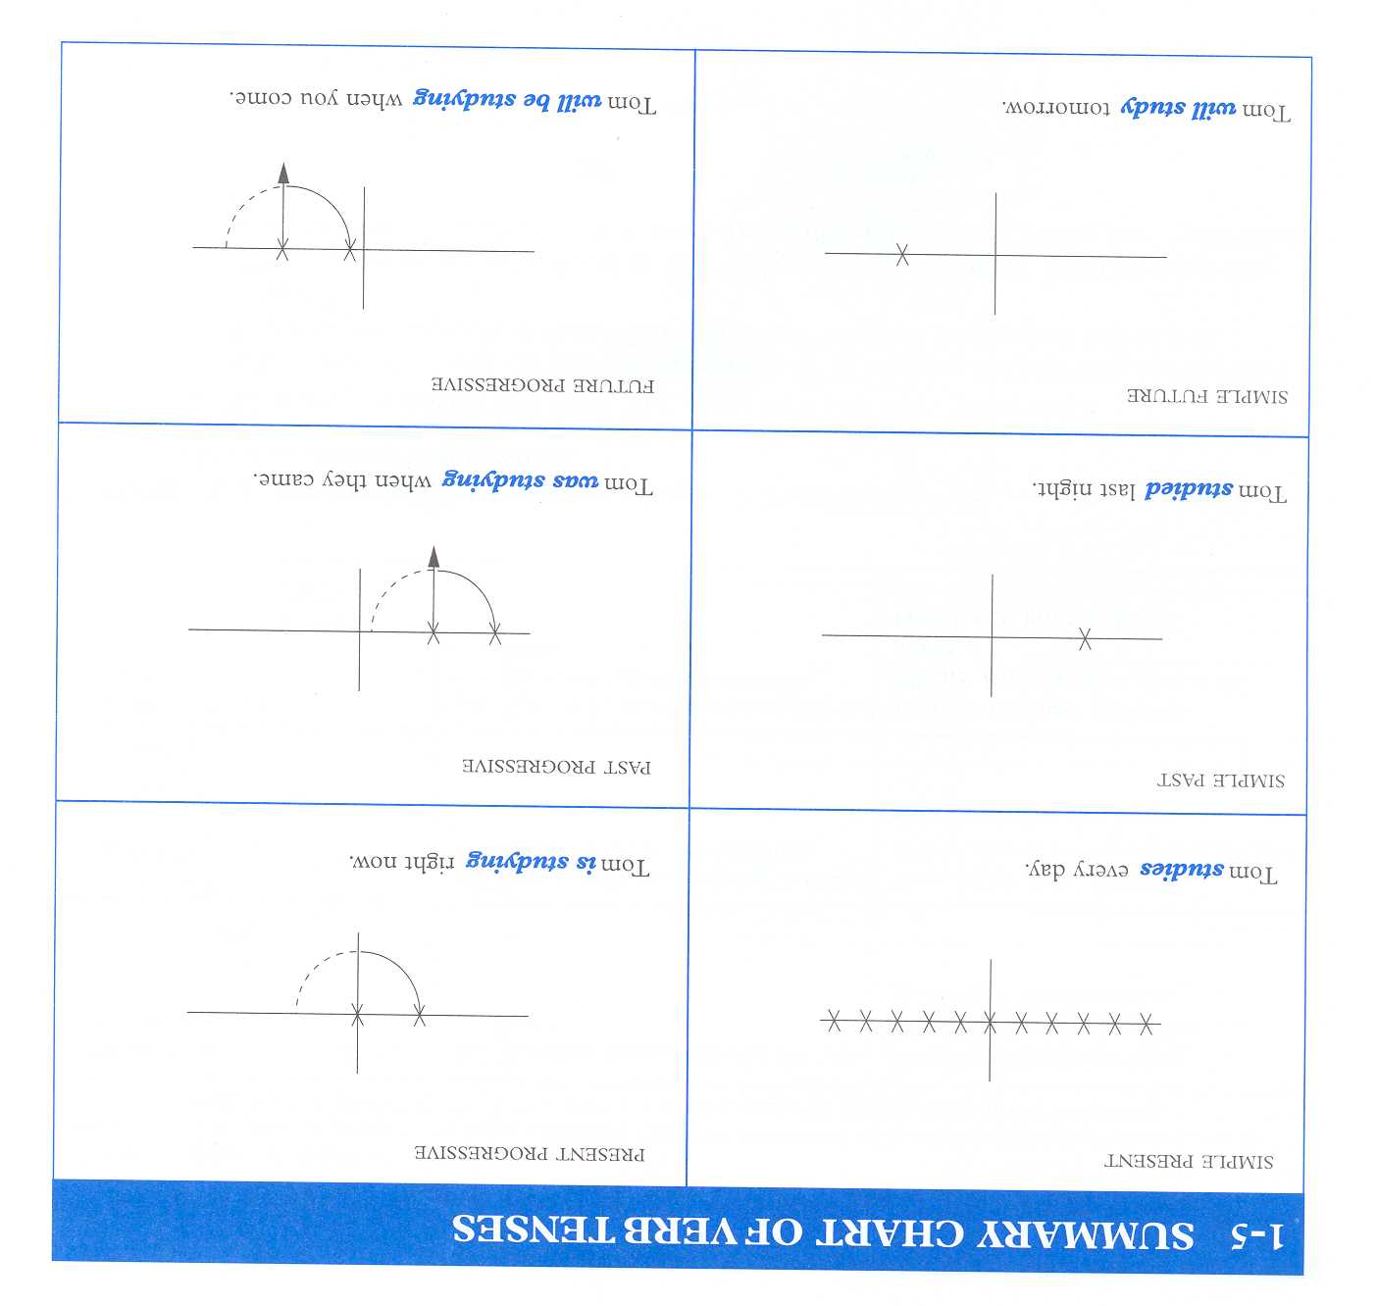
Taken from Betty Azar’s Book: Understanding and Using English Grammar 3rd Edition

